

*Abstract-* start writing here …

(Hint: you might refer to <https://ieee-dataport.org/sites/default/files/analysis/27/IEEE%20Citation%20Guidelines.pdf>)

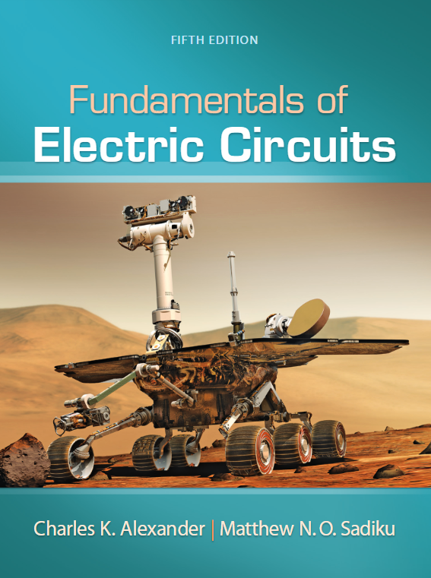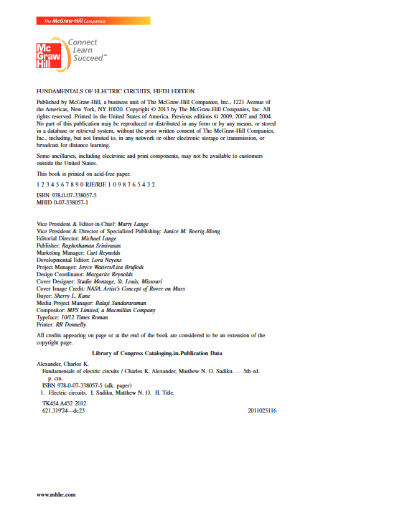

References

[1] Your answer here

Use this link to access the software <https://www.circuit-diagram.org/editor/>.

Your answer here

**Exercise-4**

The following data shows the forward voltage and current of different LED colors measured in a lab. Your task is to organize the data into a professionally formatted table with:

* Proper column headers and units
* A descriptive caption
* In-text citation referencing the table

**Raw Data:**

* Red LED: Voltage $= 1.9 V$, Current $= 12.1 mA$
* Green LED: Voltage $= 2.2 V$, Current $= 10.4 mA$
* Blue LED: Voltage $= 3.1 V$, Current $= 9.2 mA$

**Instructions:**

* Create a clean, well-labeled table.
* Add a meaningful caption below the table.
* Include an example sentence referencing the table, as if part of a report.

Your answer here

**Exercise-5**

You are given a sample paragraph below. Your task is to edit it to meet the formatting and style requirements typically expected in EE2101 lab reports.

**Sample Text**

“the circuit is Built accOrding to fig. 1 and tested using a voltmeter. we did the measurments at three points .the data is shown in table 1. it show that the blue led lights up only at 5v.the red one work at 2V.this tells us which one to choose”

Your answer here

**Exercise-6**

You’re reviewing a peer’s methodology paragraph below. Your task is to assess its **reproducibility** and improve it.

**Peer’s Methodology Paragraph:**

“We did the experiment using some resistors and LEDs. The circuit was built just like we saw in the lab. Then we turned on the power and looked at what happened. We wrote down what we saw. A multimeter was used sometimes.”

List 3–5 specific reasons why the paragraph is not reproducible.

Your answer here

**Exercise-7**

Discuss and comment on the following results

Figure 2 below shows the measured gain as a function of the load resistance for some circuit.

Figure 2: Amplifier Gain with Different Loads.

Your answer here

Table 1 below shows the output voltage of a photoresistor as a function of light Intensity.

Table 1: Sensor Output Voltage vs. Light Intensity.

|  |  |
| --- | --- |
| **Light Intensity (lux)** | **Output Voltage (V)** |
| 0 | 0.02 |
| 100 | 0.52 |
| 200 | 0.98 |
| 300 | 0.73 |
| 400 | 1.89 |

Your answer here

Figure 3 below shows the measured voltage and current across a resistor in the lab.

Figure 3: Measured voltage vs current across a resistor.

Your answer here